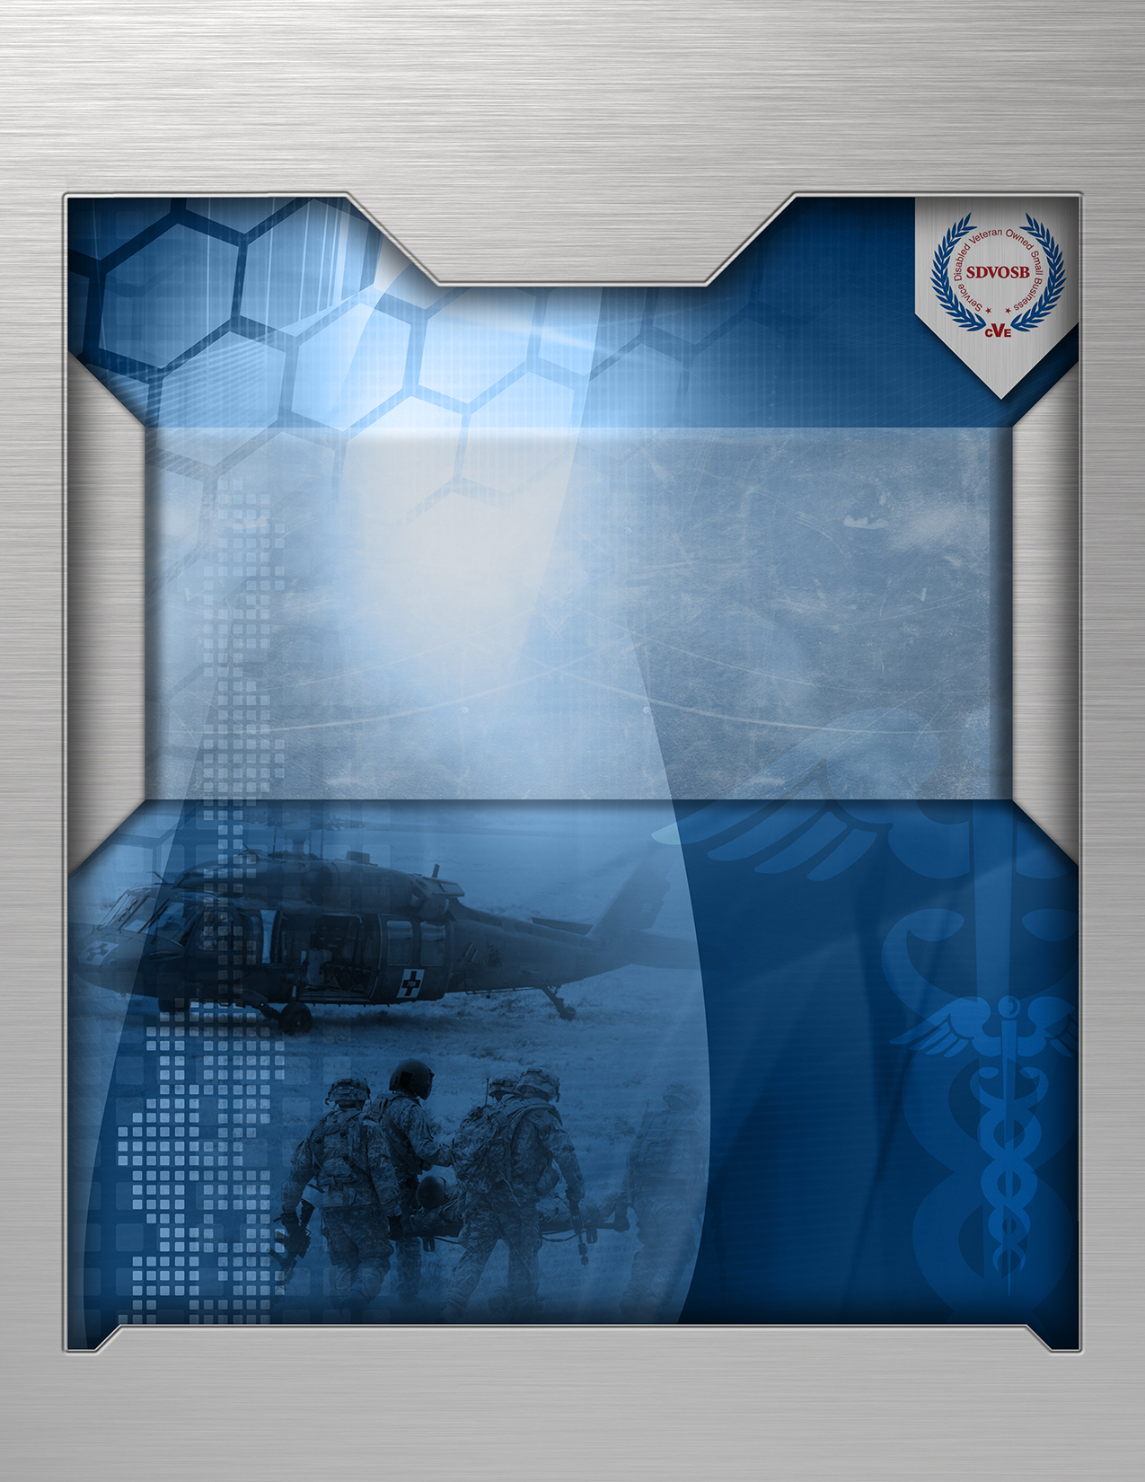

**Department of Veteran Affairs  
Technical Acquisition Center  
OneVA Pharmacy Implementation**

**VA118-15-Q-0745**

*Submitted to:* Department of Veteran Affairs  
 Technical Acquisition Center

23 Christopher Way

Eatontown New Jersey 07724

*Submitted by* Business Information Technology Solutions

3190 Fairview Park Drive, Suite 350

Falls Church, Virginia 22042

*Point of Contact* Dan McCarron | VP, Health Solutions  
email: dmccarron@thebitsgroup.com

(703) 740-8755 [o] | (540) 446-6415 [c]

*DUNS* 169939688  
*Federal ID* 20-0096487  
*CAGE Code* 33JP4  
*Classificatio*n SDVOSB

**21 September 2015  
Volume I – Technical Proposal – Discussion Version**

NOTICE: This document is the property of BITS Inc. It is being presented to the Department of Veterans (VA) Affairs in the strictest of confidence solely for the purpose of deciding whether or not to purchase the BITS Inc. services indicated herein. By receipt of this document, the VA agrees that it shall disclose this document to its employees on a need-to-know basis and that the VA shall take all reasonable steps to ensure that the document is not otherwise disclosed or distributed. In the event that the VA declines to purchase BITS Inc. services, the VA shall return or destroy all paper and electronic copies of this document.

Table of Contents

1 Executive Summary 1

2 Understanding of Requirements 1

3 Approach 2

3.1 Task 1: Project Management 4

3.1.1 Governance 5

3.1.2 Contractor Project Management Plan 5

3.1.3 Kick Off 7

3.1.4 Training and Administrative Requirements 7

3.1.5 Travel 7

3.1.6 VA Security 7

3.1.7 Reporting Requirements 7

3.1.8 Code in Flight 8

3.1.9 Project Coordination and Integration 8

3.2 Task 2: Software Development Planning 10

3.2.1 Requirements Specification Document 10

3.2.2 Entry of Requirements, User Stories and Tasks 10

3.2.3 System Design Document 11

3.3 Task 3: Software Development 12

3.3.1 Controlled Substances 12

3.3.2 Drug Matching 12

3.3.3 Medication Profile Display 13

3.3.4 Lock Out Removal 13

3.3.5 Documentation 14

3.3.6 Test Fixes and Patches 14

3.3.7 Updates to Documentation for Initial Operating Capability 14

3.3.8 Document Tasks 14

3.3.9 Other Tasks 14

3.3.10 Remote Fill VistA Modifications 15

3.4 Task 4: Testing 16

3.4.1 Planning 16

3.4.2 Test Cases and Test Scripts 16

3.4.3 Test Site Identification (IOC) 17

3.4.4 Operational Readiness Review 17

3.4.5 Unit Function Testing 17

3.4.6 Software Quality Assurance Testing 17

3.4.7 User Functional Testing 18

3.4.8 Operational Readiness 18

3.4.9 Initial Operating Capability Testing 18

3.5 Task 5: Introduction to VistA Intake Program 20

*3.5.1* Lessons Learned 21

3.5.2 Implementation Report 21

4 Labor Categories and Hours 24

Acronyms and Glossary

|  |  |
| --- | --- |
| Acronym | **Description** |
| ACP | Acceptance Criteria Plan |
| BITS | Business Information Technology Solutions |
| CDS | Clinical Data Services |
| CIF | Code in Flight |
| CMP | Communication Management Plan |
| COR | Contracting Officer’s Representative |
| CTO | Chief Technology Officer |
| eHMP | enterprise Health Management Platform |
| eMI | Enterprise Messaging Infrastructure |
| ESE/ETS | Enterprise Systems Engineering / Enterprise Testing Service |
| HIS | Health Information Systems |
| HIMIO | Health and Medical Informatics Office |
| HITI | Health Information Technology Innovation |
| IOC | Initial Operating Capability |
| IPT | Integrated Project Teams |
| KIDS | Kernel Installation and Distribution System |
| MPR | Monthly Program Review |
| MUMPS | Massachusetts General Hospital Utility Multi-Programming System |
| OIT | Office of Information and Technology |
| OSEHRA | Open Source Electronic Health Record Alliance |
| PBM | Pharmacy Benefits Management |
| PMAS | Project Management Accountability System |
| PMP | Project Management Plan |
| POC | Point-of-Contact |
| PM | Program Manager |
| PRMM | Program Risk Management Methodology |
| PSO | Outpatient Pharmacy |
| RMP | Risk Management Plan |
| RRC | Rational Requirements Composed |
| RSD | Requirements Specifications Document |
| QMCP | Quality Management and Control Plan |
| SDD | System Design Document |
| SDVOSB | Service-Disabled Veteran-Owned Small Business |
| SMP | Staffing Management Plan |
| SQA | Software Quality Assurance |
| SQA | Software Quality Assurance |
| TPOC | Technical Point-of-Contact |
| TTL | Time-To-Live |
| UFT | User Functional Testing |
| VA | Department of Veteran Affairs |
| VAIC | VA Innovation Center |
| VANDF | VA’s National Drug File |
| VistA | Veterans Health Information Systems and Technology Architecture |
| WBS | Work Breakdown Structure |

# Executive Summary

Business Information Technology Solutions (BITS), a CVE verified Service-Disabled Veteran-Owned Small Business (SDVOSB), submits its technical approach in response to Department of Veteran Affairs (VA), Technical Acquisition Center, VA118-15-Q-0745, for OneVA Pharmacy Implementation. The BITS Team is pleased to have the opportunity to “complete the work” that we contributed through the OneVA Innovation project and see this important capability matured to enterprise implementation for our Veterans and for the VA.

The VHA had a requirement to allow Veterans travelling across the United States to get their active VA prescriptions refilled at any VA pharmacy regardless of where the prescription originated. The “idea” was to expand currently available pharmacy information in Veterans Health Information Systems and Technology Architecture (VistA) to provide pharmacists direct access to any active and refillable prescription from any VA Healthcare System. OneVA Pharmacy *Implementation* project modifies the existing prototype software to expand the current capability and provides assistance in the development of documentation to support a national rollout in March 2016.

The BITS Team developed the pilot and has experience in several VA projects with proven results. Together, we have the product knowledge, Project Management Accountability System (PMAS) and testing experience to successfully deploy this product. The BITS team brings: agile methodologies, collaborative decision making, expert leadership, holistic thinking and innovative solutions that deliver value. Our team understands the value, brings stakeholders into the change process, and drives innovation through collaboration, creativity, design principles and partnership. We bring the same team that supported the successful prototype which was fast-tracked into the VistA Intake Program for the next steps towards National Deployment.

# Understanding of Requirements

OneVA Pharmacy and this integration provides a foundation to build and extend new capabilities to the Veteran, who are better served by integrating virtual care into pharmacies, using technology to close the gap between the previous quality of information, and the Veteran's level of engagement. A well-designed OneVA Pharmacy builds upon the history of VHA, and advances in modern technology to allow Veterans to take a more active role in their own health care.

In Fiscal Year (FY) 2014, the VA sought research and development of a prototype solution that would enable the VistA system to exchange and act on any portion of a patient’s prescription from any VA facility independent of where and when the order was made. This capability was designed to allow Veterans to fill their prescriptions at other VA facilities and to complete pharmacy orders while in transient from any location, much as commercial operations, like CVS and Walgreens, allow their customers to do. In the commercial sector, this has long been considered a standard of practice. BITS supported the cooperative effort between the Chief Technology Officer (CTO), the Health and Medical Informatics Office (HMIO) and the VA’s Office of Information and Technology (OIT).

The Proof of Concept provided for:

* Identifying the correct patient and accessing personal health information so each VistA system can query the VA Enterprise and find all instances of VistA containing active prescriptions for the correctly identified individual patient.
* The ability to locate a patient in the environment, a means was developed to query and extract all of the prescription information from each remote site for display in the local VistA environment, where the patient was being seen.
* Allowed the local VistA the ability to perform the prescription fulfillment workflow(s), based on the information gathered from the remote system, while blocking other systems from acting on that individual’s prescription at the same time.
* Make an update to note the prescription activity that had occurred, with all the associated workflow processes.

The BITS Team completed the proof of concept work and successfully proved that this could be accomplished outside of the VA’s network, in a virtual testing environment (Innovations Sandbox).

The effort to advance the prototype to a production ready pharmacy capability throughout the VA can be realized with a focused effort of the program and all support entities. The addition of additional capabilities, systemic enhancements for performance, documentation, and testing are comprehensive, understood and achievable.

# Approach

The BITS Team will refine the prototype and provide a complete software product. We will modify the existing VistA software to allow pharmacies at OneVA locations to make changes and address prescriptions and removes controlled substances from the active refill list, through a middleware model that meets the current VA standards. The effort to remove controlled substances includes those identified as such by the VA’s National Drug File (VANDF), those described by varying state levels, and incorporates other business rules, as determined by the PBM. We will provide all required documentation for acceptance of the product by the Technical Review Board for the introduction to the VistA Intake Program, complete all testing activities and train for the new product according to the VA’s tailored set of PMAS documents consistent to the identified approach. It is our understanding that the documents required are a subset of the standard PMAS documentation. Within 30 days, the government and the BITS Team will agree to the specific PMAS modification for OneVA Pharmacy Implementation and all documents required.

The BITS Team employs a VA-centric approach to developing, testing and deploying the OneVa Pharmacy solution as illustrated in *Figure 3.0.* For this six month effort we have broken down the task to Sprints within a single increment as illustrated in Figures 3.1 through 3.3. Our approach includes an integrated project team developing software in an Agile framework – providing VA with incremental delivery of artifacts and integrated delivery packages. The BITS Team’s approach explains “how” we meet the need with proven processes and techniques.

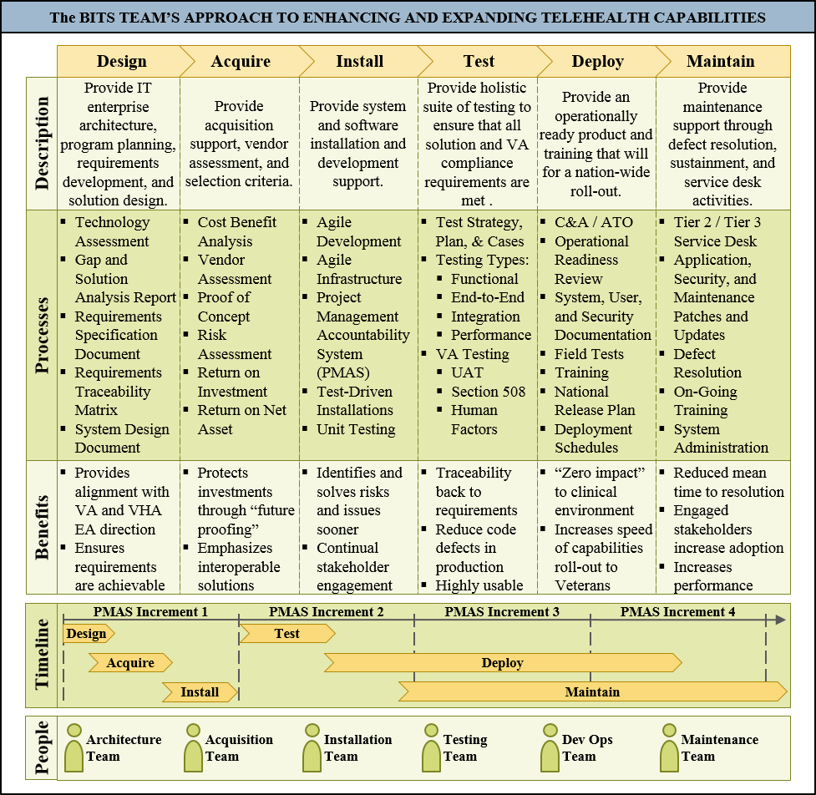

Figure 3.0: Integrated Team Supports Feature Development in an Agile Framework

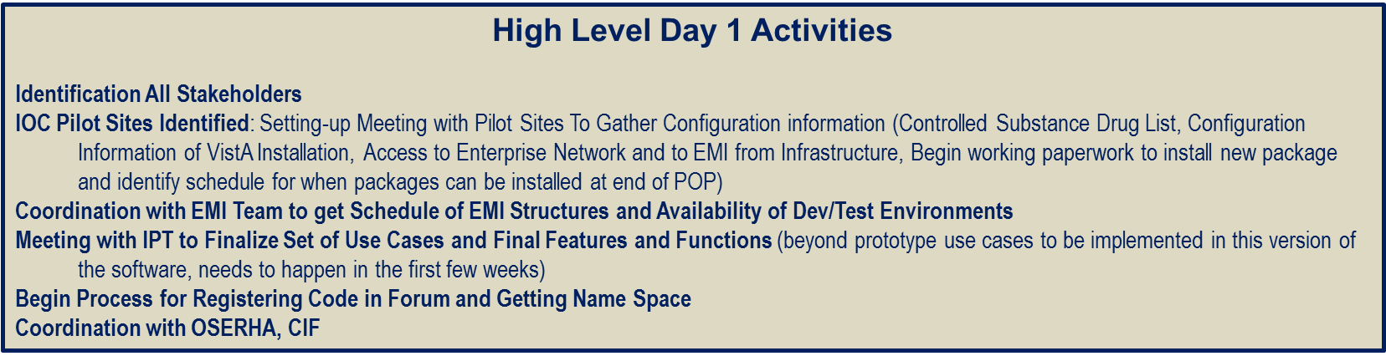

Figure 3.1: High Level Day 1 Activities

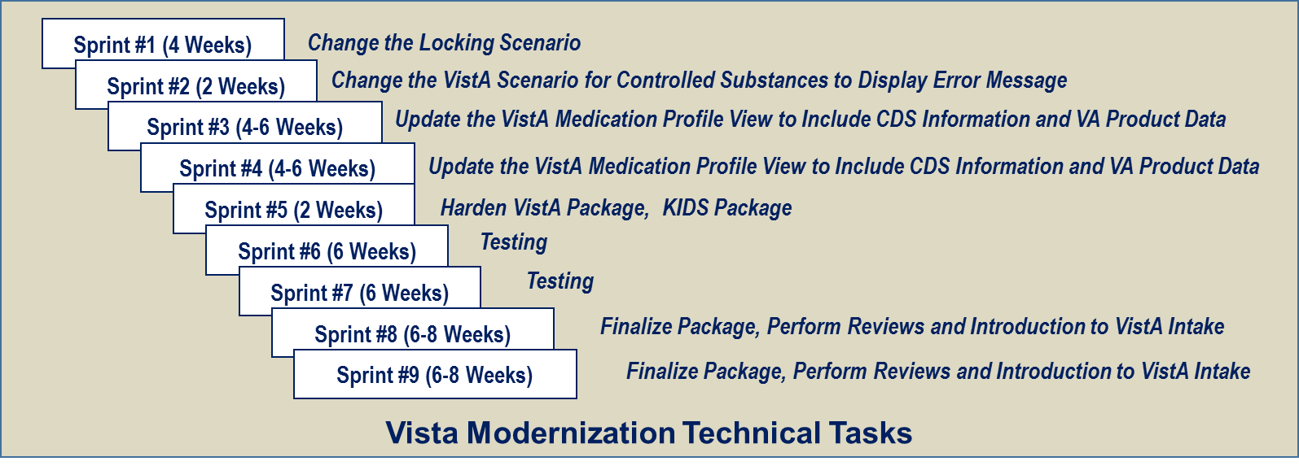

Figure 3.2: Vista Modernization Technical Tasks



Figure 3.3: EMI / RX Manager Technical Tasks

## Task 1: Project Management

Project management underpins the project delivery by ensuring all support is managed in a controlled way. The BITS Team’s approach ensures decisions are made by the right people and based on the correct information. The governance role includes audits or peer reviews, developing project and program structures and ensuring accountability. Transparency provides information with a single source of the truth. Information is relevant and accurate to support effective decision-making. Reusability keeps the project teams from reinventing the wheel, by being a central point for lessons learned, process templates and best practices. Delivery support ensures project teams are efficiently doing their jobs well, by reducing bureaucracy, providing training, mentoring and quality assurance. And lastly, traceability helps in managing documentation, project history and organizational knowledge.

### Governance

The BITS Team’s project management structure (***Figure 3.4***) and Project Management Plan (PMP) defines the roles and responsibilities, delegations of authority, and escalation procedures required to ensure clear communication and project visibility, and allows issues to be resolved within the project team, the Government leads, and its organizational components. This program management approach provides a seamless, transparent team model to effectively and efficiently manage sub-contractor relationships, thereby ensuring the highest level of performance to the team, and also includes internal, day-to-day management, peer reviews, and team meetings to identify and correct issues. The BITS Team is an integrated project team (IPT), with highly-experienced staff. BITS represents the single point-of-contact (POC) for the government, is responsible for managing our sub-contractor (QBase, as acquired by SRA), and ensuring our team provides seamless, quality services that meet or exceed standards. As we have proven over the last several years, we collaborate with our sub-contractor in a manner that allows us to function as a seamless, well-integrated team. The lines of authority for this project are distinct from the CEO, BITS, Mr. Dan McQuay for oversight. The Program Manager (PM), Mr. Josh Temkin extends to the team, internal project milestone decisions, and issue resolution. The PM develops and manages the project schedule, acts as the conduit to the Contracting Officer’s Representative (COR), conducts periodic status updates, and ensures the right team is fielded and completely engaged.

Figure 3.4: BITS Team’s Program Management

### Contractor Project Management Plan

The BITS Team’s integrated PMP approach drives task planning, directing, monitoring, organizing, producing, reporting, scheduling, staffing, timeline, and tools, to ensure project effectiveness, along with on-time and on-budget completion. This flexible, management approach can be tailored to meet the needs of each individual task, and easily accommodates both standard and short turnaround task requirements. The PMP is a formal, ProPath approved document that guides project execution and control. It documents planning assumptions and decisions, facilitates communication among VA, VHA, and other stakeholders, while documenting approved scope, resource, and schedule baselines. It states how and when objectives are to be achieved, by presenting the major technical products, milestones, scheduled activities and required resources. As part of the kick off, the BITS Team’s project and business planning specialists explain the details of their intended approach, work plan, project schedule and PMP (*Deliverable 5.1.1.A*). These plans are approved by the Technical Point-of-Contact (TPOC). The PMP defines the BITS Team’s approach to meeting the objectives and project deliverables of the respective units. Our business planning experts leverage their current knowledge and reference the management processes and control mechanisms currently in place, and provide monthly updates to the following components of the PMP: Communication Management Plan (CMP), Quality Management and Control Plan (QMCP), Staffing Management Plan (SMP), and Risk Management Plan (RMP). The following section provides the details of these updates.

* **Communications Management Plan**. The BITS Team recognizes the importance of a current CMP that provides guidance, as well as for communicating across the VA, VHA and with other stakeholders. Communication methods include: informational announcements, awareness announcements, formal deliverables, and status reporting, as well as guidance documents, such as our methodology and standards. The CMP provides the details on how we coordinate and execute planned, routine, and ad hoc data collection reporting requests.
* **Quality Management and Control Plan**. The QMCP defines how to effectively manage project quality from planning to delivery. It defines a project’s quality policies, procedures, criteria and areas of application, and staff roles, responsibilities, and oversight authorities, and is intended to guide the project lead, project team, project sponsor and other stakeholders in carrying out the plan. The BITS Team’s QMCP requires that all work/deliverables be subject to self-inspection and peer reviews.
* **Staffing Management Plan**. The SMP details the project’s staffing requirements and the strategy designed to staff the project, including reach-back capabilities and resource transitioning as shared in the response. The SMP adheres to the VHA Staffing Plan’s policies and procedures. The Staffing Plan is presented during kick off.
* **Risk Management Plan**. The RMP contains an analysis of likely risks, impacts and accompanying mitigation strategies. There are four goals: avoid risk, control/mitigate risk, accept risk, or transfer risk. The PM updates the RMP to accurately show preparation for identified, foreseeable risks, a full understanding of estimated impacts, high to low, and accompanying mitigation strategies. Consistent with the BITS Team Program Risk Management Methodology (PRMM), risks are identified as they arise, adjudicated using a structured process, and tracked to resolution. The risks reported in the PMP are be provided as separate documentation in the form of a risk issue log (*Deliverable 5.1.1.D)*. The Risk Issue Log template is provided through ProPath. The updatedPrimavera Risk Issue Log is provided five day after an update (*Deliverable 5.1.2.D)*.
* **Schedule in Accordance with the Work Breakdown Structure.**The BITS PM develops and maintains the schedule and work breakdown structure. The Program Manager and government leadership validate the Project Schedule, accompanied by a Work Breakdown Structure (WBS) to track milestones at a level of detail sufficient to manage the scope, schedule and cost performance of the project, and commensurate with the risk associated with work performed. The Project Schedule and WBS are completed in the Primavera Project Schedule and updated quarterly to document all tracked tasks and milestones, as well as any schedule changes, change requests and issues. The schedules reported in the PMP are provided as separate documentation in the form of a Primavera Project Schedule (*Deliverable 5.1.1.C)* and is delivered ten days after award. The updatedPrimavera Project Schedule is provided 30 day after an update (*Deliverable 5.1.2.C)*. The project schedule meets requirements established by modified “*ProPath and PMAS”.*

### Kick Off

The BITS Team schedules a kick-off meetingin coordination with the government Leadership immediately after task order award. At the meeting, the BITS Team presents an overview of our approach and establishes schedules, procedures, and points of contact necessary to conduct the tasks outlined in the PWS (*Deliverable 5.1.1.B).*

### Training and Administrative Requirements

All proposed BITS Team members have completed and are current on VA required Mandatory Training. As team members are added, they complete the following training: Contractor Rules of Behavior, Cyber Security, Privacy and Information Security Awareness and mandatory training during the prescribed timeframe, using the VA Talent Management System.

### Travel

The BITS Team plans and forecasts travel requirements to the best of our ability. We obtain VA PM and TPOC written approval, prior to initiating any travel. The BITS Team is experienced with managing this process, from our various engagements with VA, and adheres to Federal Travel Regulations and FAR 31.205-46.

### VA Security

The BITS Team is fully familiar with the VA process for security on-boarding, and employs a comprehensive checklist that has been verified by two separate, independent reviews, before submitting to the designated personnel. Our team understands the requirement for having background checks completed before any of the required tasks can be assigned to an employee or partner (sub-contractor). The BITS Key Personnel are currently VA cleared and operating in support of other VA and VHA efforts. The BITS Team complies with the VA onboarding contractor process, the PM ensures that the team onboarding POCs are: (1) immediately notified and provided with the correct documentation (personnel change request form, resume, updated contract roster), (2) all background investigation documents are completed and sent to the CO, and (3) the SF-85 security questionnaire provided through e-QIP and (4) all additional security forms and training completed and submitted in a timely and efficient manner.

### Reporting Requirements

The PM generates a weekly task report, in conjunction with the team, to communicate an up-to-date status of the BITS Team’s work efforts, issues, delays, and items that may need attention. The BITS PM briefs the COR/project manager(s) each week and provides a Weekly Task Report to discuss and address risks, staffing, burn rate, performance, and other topics deemed necessary by the COR. The PM uses these weekly reports to create the Monthly Progress Report (MPR) and update the PMP (Deliverable 5.1.2.A). The BITS Team submits a comprehensive MPR to keep the Government Lead(s) informed of the progress of this effort, and provides status on all work efforts, including expenditures, billings, progress, deliverables status, and any problems/issues encountered. The BITS Team notifies the TPOC, and CO, in writing, if problems arise. The TPOC serves as the primary contracting POC for the BITS Team. If any issues arise that could potentially affect project performance, the BITS PM alerts the VA PM, CO, and the COR, as appropriate. The MPR includes the following:

|  |  |
| --- | --- |
| **Monthly Progress Review** | |
| * Change Request Status | * Problems and Resolution |
| * Contractor Staff Roster | * Schedule Status |
| * Instructions/Explanations for Data Element | * Status of Background Investigations |
| * Issues Status | * Status Summary |
| * Minutes of Status Meetings | * Work Completed |
| * Performance against PMP | * Work Planned |
| * Performance against Schedule |  |

### Code in Flight

Code in Flight (CIF) is a critical aspect of delivering reusable code for implementation to VA OIT on a regular and incremental basis for OIT to determine value and distribute the code into the broad expanse of VistA, VistA Evolution, the eHMP and finally to the Open Source Electronic Health Record Alliance (OSEHRA) membership for use by all participants. BITS, as a corporate member of OSEHRA, has been engaged to the principles, execution and transitions necessary for CIF processing since 2013. We co-chair the OSEHRA Architecture Work Group, and our engineers and SMEs remain informed both to the processes of CIF and to the changes affecting the VistA code base. The BITS Team provides a code release from both VistA at the end of each sprint, which take 2-3 weeks to complete. This allows us to generate, track and manage multiple releases throughout the development process. For example, we develop the VistA code within the approved VA Development environment. KIDs (Kernel Installation and Distribution System) files will be provided at the end of each sprint. The KIDS builds contain all of the needed data dictionaries, HL7 logical links, routines, and forms for the VistA software. We deliver the required code and documentation to reflect our Sprint cycle process so that this information is refreshed, at a minimum, on a Monthly basis. (*Deliverable 5.1.3.E***)**.

### Project Coordination and Integration

#### VistA Patch Coordination

The BITS Team coordinates weekly VistA patch status meetings with the VA to ensure we provide the most up to date information. Since development cannot occur within forum itself, once we complete Software Quality Assurance (SQA), we port the code from the development system into forum, and use a patch in the Outpatient Pharmacy (PSO) namespace to accommodate the VistA Pharmacy enhancements.

#### Integrated Project Team

The Integrated Project Team (IPT) brings diverse elements together to form a unit that willingly shares information, balances conflicting priorities and jointly plans and executes the OneVA Pharmacy Implementation mission. The membership and depth of an IPT is dependent on the project variables but includes: numerous stakeholders, Program Offices and Project to include VA’s Enterprise Messaging Infrastructure (eMI), Vista Interface Engine (VIE) and Clinical Data Services (CDS). The BITS Team attends and participate in weekly IPT meeting. Our team is responsible for preparing agendas, approving previous minutes, attendees, and capturing meeting minutes (*Deliverable 5.1.4.A***)**.

#### Project Daily Stand-up Call

The BITS Team uses daily stand up meetings, as part of our software development methodologies (*Deliverable 5.1.4.B***)**, to make commitments to team members. These allow participants to know about potential challenges, as well as coordinate efforts to resolve difficult and/or time-consuming issues. The stand-up has particular value in agile software development processes. The meeting takes place at the same time and place every working day. We review the progress of the tasks assigned to the individuals in the Rational Tools Composer (RTC). The meetings are a communication vehicle for team members and not a status update to management or to other stakeholders. Representative stakeholders are invited, regardless. Meeting promote follow-up conversation, as well as identify issues, before they become large problems. The practice also promotes closer working relationships, reduces follow-up conversations and its short structure results in a higher rate of knowledge transfer – a much more active intention than the typical status meeting.

**Resources Supporting Project Management**

| **Labor Categories** | **Task 1** |
| --- | --- |
| Technical/Project Manager | 220 |
| SME-I | 80 |
| System Architect | 40 |
| Vista Developer | 40 |
| Project Coordinator | 200 |
| Trainer/Tech Editor | 70 |
| QA Tester |  |
| Test Lead | 40 |
| ***Total*** | 690 |

**Deliverables**

|  |  |  |  |
| --- | --- | --- | --- |
| **Task** | **Description** | **Quantity** | **Due Date** |
| **5.1.1.A** | **Project Management Plan** | 1 | * 30 days after contract award and updated monthly |
| **5.1.1.B** | **Kick-off Meeting** | 1 | * Agenda: 5 business days after contract award * Kick-Off: 10 day after contract award |
| **5.1.1.C** | **Primavera Project Schedule** | 1 | * 10 days after contract award |
| **5.1.1.D** | **Risk Issue Log** | 1 | * 30 days after contract award |
| **5.1.2.A** | **Monthly Progress Report** | 12 | * Due 5th day of month |
| **5.1.2.B** | **Progress Meeting Minutes** | 1 | * 2 days after each month progress report |
| **5.1.2.C** | **Updated Primavera Project Schedule** | 1 | * 30 days after an update |
| **5.1.2.D** | **Updated Risk Issue Log** | 1 | * 5 days after an update |
| **5.1.3.E** | **Open Source Code In Flight Submission** | 1 | * 30 days after award |
| **5.1.4.A** | **IPT Meeting Minutes** | 1 | * 3 days after the IPT, electronic submission to VA PM, COR and CO |
| **5.1.4.B** | **Daily Stand-up Call Meeting Minutes** | 1 | * Daily |

## Task 2: Software Development Planning

### Requirements Specification Document

The BITS Team develops the OneVA Pharmacy Implementation solution through an Agile Process we starts with the capture, documentation, and refinement of stakeholder requirements in order to establish a product backlog. The requirements are clear in direction and content as provided. We have a Change Management (CM) process and should expansion or adjustment of the requirement arise, we employ that process to rapidly validate, communicate and provide a Risk Analysis to substantial changes. OneVA is largely agreed upon, is short fused and many of the CM factors may be moved into “future.” Our base document is the Business Requirements Document for the production ready version of the OneVA Pharmacy solution. This is synchronized through the Requirements Traceability Matrix (RTM) and the RSD and is managed through CM. By documenting the functional and non-functional requirements in the Rational Requirements.

Composer and a Requirements Specification Document as defined by the modified ProPath template. The requirements once collected, refined, and documented become part of the RSD (*Deliverable 5.2.A***)** and signatures are obtained signing off on the final set of requirements to be implemented as part of the project. The RSD is updated with the requirements. Epics, User Stories, and Tasks will be created to track the progress of development throughout the project. Tasks will include development, documentation, and testing for both the VistA and non-VistA requirements. Once a task is complete, it will be marked as either ‘Ready for review’, or ‘Done’, and text will be added to the task indicating what the solution is.

### Entry of Requirements, User Stories and Tasks

The BITS Team uses the finalized set of requirements as its products backlog, from which it derives and builds EPICs and User Stories, and creates both the technical and testing tasks required to design, implement and deploy the set of operational capabilities for each sprint performed under the OneVA Program. We document the EPICS, User Stories, and tasks within the RTC (*Deliverable 5.2.B***)**. During Sprint Planning, we measure tasks by shirt sizes (Small, Medium, and Large), with each size representing an anticipated block of work in hours with a large task not exceeding 8 hours of work. From our prior work, developing the proof of concept, the BITS team worked with functional stakeholders on two major EPICs to prove the feasibility and capabilities of the OneVA Solution and approach. The first of these EPICs focused on the ability of remote VistA instances to query, find, and view locally the set of active prescriptions available to the patient from across the VA enterprise. The second EPIC explored the ability to act on an order remotely (from a non-originating system), to fill and dispense the prescription locally. This effort resulted in User Stories of acting remotely on the order by decrementing a refill count on the originating system and then providing information about the dispensed order. We developed additional user stories of finding the drug in the fulfilling system, printing labels, and decrementing the inventory, along with exercising the existing workflows for dispensing a drug, as if the order had originated from the dispensing VistA.

These Epics and Use Cases are expanded on, hardened, and finalized as part of developing the production ready solution, and serve as initial use cases for testing and verifying the new system’s functionality. The BITS Team ensures gathering all functional and non-functional requirements by meeting with the project stakeholders. Once all requirements are identified and approved, they are entered into Rational Requirements Composed (RRC) for tracking.

### System Design Document

As the BITS Team performs each sprint, and brings the prototype solution to a production level ready state, it documents the designs, workflows, data structures, messages, and configurations of software components in the System Design Document (SDD) (*Deliverable 5.2.C*). The BITS team iterates this document, building and enhancing the solution as each sprint is completed, and documenting that requirement, and its associated test cases, and the improved design through each release. The BITS Team presents the solution, architecture, workflows, and design to the stakeholders during sprint reviews, and to other review boards including the Architecture and Engineering Review Board, and OI&T Service Delivery and Engineering Reviews. The BITS Team uses the approved SDD ProPath template for documenting its designs. To ensure that the OneVA Pharmacy solution can proceed through a delivery review, the BITS Team develops the following artifacts: Acceptance Criteria Plan (ACP), ESE Release Readiness Office Registration Form, Enterprise Operations Intake Form, Testing Intake Form, ASSESS Form, Assumptions Verification Letter, Field Operations Resource Request Form, Operational Acceptance Plan, SEDR Request Form, ETA Compliance Checklist, and Requirements Traceability Matrix (RTM). In developing these assets the team presents interim versions for periodic review and discussion with the government and stakeholders, throughout the lifecycle of the project.

**Resources Supporting Software Development Planning**

| **Labor Categories** | **Task**  **2** |
| --- | --- |
| Technical/Project Manager | 120 |
| SME-I | 140 |
| System Architect | 160 |
| Vista Developer | 160 |
| Project Coordinator | 120 |
| Trainer/Tech Editor | 120 |
| QA Tester | 220 |
| Test Lead | 195 |
| ***Total*** | 1235 |

**Deliverables**

|  |  |  |  |
| --- | --- | --- | --- |
| **Task** | **Description** | **Quantity** | **Due Date** |
| **5.2.A** | **Requirements Specification Document that meets the modified ProPath template** | 06 | * 30 days after award and updated monthly |
| **5.2.B** | **RRC and RTC Entry of requirements, user stories and tasks with proper links established that meets the modified ProPath template** | 06 | * 30 days after award and updated monthly |
| **5.2.C** | **System Design Document** | 06 | * 30 days after award and updated monthly |

## Task 3: Software Development

Upon completing the development planning task, the BITS Team builds upon the original prototype solution for OneVA Pharmacy and develops the version ready for introduction to Vista Intake Program. As an initial step toward developing the solution, the team identifies gaps in the current prototype, against the finalized set of requirements. This includes re-evaluating the messages used, terminology sets used for exchanging prescription information, and the data workflows used in the VA Innovation Center (VAIC), against the actual VA enterprise. As an example, we recognize that the developing the production solution requires the implementing more robust error handling and recovery, should the enterprise deployment find unreachable systems, when performing a write or update to a prescription from a remote filling system. We also recognize that the deployed solution needs to be migrated to a different operating stack including the eMI, and have planned our software development tasks accordingly. Other initial development tasks include finalizing the approach and implementing the query of the VA Master Veteran Index (MVI) to find a patient at the enterprise, and identify locations where the patient has been seen, as part of the patient cross reference index. This service provides a key part of querying specific Vista instances for a patient’s active prescriptions rather than a full enterprise polling and querying of all VistA instances. We are creating a new patch in the Outpatient Pharmacy (PSO) namespace. This patch includes all of the VistA side components needed for fulfilling the remote-prescription refill functionality. Prior to sending the patch to the VA SQA team, primary and secondary developer review checklists are completed. We are also sending the Data Dictionary changes to the appropriate group for validation/verification. All VA standards and conventions are followed within the VistA logic. BITS ensures the project can proceed to Enterprise Release Management by updating the documents in software planning section in addition to the Release Registration, Testing Intake, CP&R and ASSESS forms.

### Controlled Substances

While demonstrating the prototype’s capability, we recognized that handling controlled substances represents a complex use case, with different business rules, based on facilities and their locations, as governed by policy and local law. The prototype filtered these active prescriptions out of the returned information, when inquiries were made to the patients’ medication profile from multiple VistA systems. As part of developing the production version of the solution the team modifies this system behavior to send a complete medication profile on the patient from all VistA’s, to an inquiring VistA, and changes the logic of the handling of these substances to prevent dispensing a controlled substance from a remote prescription, by displaying a message within VistA that informs the user that it cannot be refilled. This modification requires changes to the business logic developed in our Massachusetts General Hospital Utility Multi-Programming System (Mumps) package that enables the viewing and acting on remote orders within VistA, and a modification to the algorithm that returns a set of active pharmacy orders from remote VistAs which currently filters out controlled substances.

### Drug Matching

As part of the prototype, the BITS team demonstrated the need to have a drug mapping table between VistA systems, as a result of items being potentially different between sites, as well as drug name spellings and potentially NDC codes. In developing a production capability for OneVA Pharmacy, we modify the workflow logic to include an enterprise look-up of drugs using VA Product to find a match and translate the returned values to values understandable by the querying system. In return, when a remote prescription is filled, the VA Product capability is queried and used to allow the update message to be received by the originating VistA and processed accordingly. Translating values and their look-up occurs within the RX Manager, as part of the prototype and are replaced with the eMI as part of the porting process of the RX Manager to the eMI.

### Medication Profile Display

For the prototype, the BITS Team modified VistA to display and annotate all local vista and remote vista prescriptions for a selected patient in the prescription select and dispense workflow screens. For the production solution, the BITS Team enhances this capability by utilizing data from the CDS. To accomplish this, the BITS Team modifies the VistA code to display the new information retrieved from the CDS within the existing VistA Screens, and works with the functional stakeholders on the design and layout of that information. The BITS Team also modifies the RX Manager’s data workflows to include queries and data aggregation from the CDS, as part of the Use Case to query remote vistas aggregate, and return to the calling VistA system, the complete medication profile of the patient. This part of the task is also part of the work to migrate the data flows and aggregation algorithm of the prototype from the existing RX Manager to the eMI. As part of the testing of this capability we demonstrate that the exchange of information is done in a secure manner according to VA regulations for Privacy and Security.

### Lock Out Removal

The BITS Team developed and demonstrated a prototype with the ability to “lock” a prescription record remotely, while it was being acted on. While demonstrating this capability, it was discussed that a lock may become permanent, if the remotely acting system could not update the system of record to remove the lock, due to a network error or if the remote process was abandoned. In developing the production solution, the BITS team modifies this capability within the VistA code to enable VistA to remove the remotely placed lock on a record, if the record is not updated, or the locked is not removed within 5 minutes of establishing the lock. We perform this by adding Time-To-Live (TTL), as part of the modifications to the prescriptions file and tables and implement VistA processes that monitor this TTL field to remove the locks within the given time limit.

While developing the OneVA Pharmacy Prototype, we evaluated different approaches toward querying, aggregating and routing calls between VistA systems that allowed remotely updating prescriptions, based on fulfilling the prescription by a non-originating VistA. The RX Manager was designed with a SOA infrastructure in mind, and because the eMI was not available at the time of the original project, we created orchestration workflows and tools that demonstrated how to perform a call to find and collect patient medication data, as well as managing the process for updating remote prescriptions. The RX Manager consists of three parts: HL7 Receiving Endpoint and Processor, Prescription Query Service, Prescription Lock / Fill Service.

In the production system we migrate these three services and associated workflows and aggregation technique to use the eMI and VistA DHCP Health Level 7. The BITS Team performs this work by configuring the eMI message broker to accept the pharmacy query request from VistA, developed for the prototype to replace the MLLP HL7 Receiving Endpoint. We will configure the request to initiate an orchestrated workflow of service calls including the VA mVI to find other locations where the patient has medical records, and use the eMI to initiate queries to and aggregate the returned data into a single returned message in response to the query to replace the Prescription Query Service. We also add the functionality of querying and using information from the VA Product and CDS, as part of migrating and replacing the Prescription Query Service. To support remote fills, we port and migrate the Prescription Lock/Fill Service to the eMI along with the VistA Side RESTful Web Service to enable this capability on the desired eMI stack. As the software was written in Java, we incorporate the VA MVI, Products Services, and recreate the query calls of the Prescription Query Services within the eMI, thereby replacing the core functionality of the RX Manager. We test the redeveloped RX Manager to ensure that the initial and new use cases are functional using the eMI, and demonstrate that exchanging sensitive patient information is done in a secure manner according to VA regulations for Privacy and Security.

### Documentation

The BITS Team produced Software Design Documents, User Guides, and Test Cases as part of developing the initial OneVA Prototype. Under this project, the BITS team enhances and updates these documents to include changes to the design based on the deployment to the eMI and inclusion of new services and capabilities, based on the finalized requirements. The BITS team performs these tasks to keep the technical documentation current for required modified PMAS Reviews including Operational Readiness Review, Initial Operating Capability Entry and Ext, and preparation for National Deployment.

### Test Fixes and Patches

The BITS Team captures testing results from integration, functional, user, and operational readiness reviews and initial operating capability testing noting any defects and works with the customer to assign severity and order of precedence in order to develop patches for all found and confirmed defects. The BITS Team creates test cases to replicate the identified defects, develops and tests the solution to the identified issue, and documents the resolution as part of the defect fix and patch process.

### Updates to Documentation for Initial Operating Capability

The BITS Team develops, updates, and maintains any remaining documentation required for Initial Operating Capability (IOC) and National Release. These documents include the Authority to Operate, Disaster Recovery Plan, ESE ETS Independent Testing Service Package, Incident Response Plan, Information System Contingency Plan, Installation Back-out/Rollback Plan, Interconnection Security Agreement Memorandum of Understanding, Privacy Impact Assessment, Production Operations Manual, Risk Assessment, Section 508 Compliance Self Certification, Section 508 Conformance Validation Statement, Security Guide, Service Level Agreement, Signatory Authority, Software Configuration Management Procedures, System Configuration Management Plan, System Security Plan, User Guide, and Version Description.

### Document Tasks

Using the RTC tool, all tasks are managed, developers update and report status on completion, test results updated as part of the development lifecycle and during each sprint that are assigned to them.

### Other Tasks

The BITS Team recognizes developing a deployable production ready version of this solution other tasks will be required. These include registering the OneVA Pharmacy package with VA to receive an official namespace for deployment and certification as a Class I product. Scanning software for vulnerabilities; using tools like HP Fortify and other VA approved tools to certify the code does not contain known exploits or weakness. Performing and reporting on MUMPS development compliance checks through by executing XINDEX. Creating a deployable KIDS packages utilizing the approved name space. Using a deployable package of software, configurations, and workflows for the eMI that replaces the RX Manager.

### Remote Fill VistA Modifications

The BITS Team modifies the remote-refill logic to filter out controlled substances. This can be done by either removing the item from the list entirely, or displaying the item but allowing no action to be taken. Drug matching functionality is being enhanced to use the VA Product to find a match. The core vista logic for retrieving information is being modified to utilize data from Clinical Data Services. The existing logic that locks out a remote user is being removed from the PSORR* routines. This ensures that the remote users are not locked out of a patient record, while another site is taking action on a prescription. The communication and data collection logic will need to be modified within the PSORR* routines. The new approach utilizes Enterprise Message Infrastructure (eMI) and Vista HL7, and the PSORR* routines are configured to read and send pharmacy HL7 messages. All previously created documentation is being updated to reflect all changes made during the development. Any defects encountered during the development and testing phases are tracked in Rational, and remedied as quickly as possible. All Technical, System, and User documentation is updated to correctly outline the product, how it functions, and how it should be used. During the development process, all tasks in RTC will be updated by the developers in a timely manner. Upon completing development, all required IOC documentation is prepared, including patch notes, primary and secondary developer reviews, SQA checklists, and any other related documents. A VistA patch is being created within FORUM and released via the National Patch Module (NPM) (*Deliverable 5.3.C)*.

**Resources Supporting Software Development**

| **Labor Categories** | **Task 3** |
| --- | --- |
| Technical/Project Manager | 280 |
| SME-I | 80 |
| System Architect | 340 |
| Vista Developer | 340 |
| Project Coordinator | 80 |
| Trainer/Tech Editor | 120 |
| QA Tester | 240 |
| Test Lead | 217 |
| ***Total*** | 1697 |

|  |  |  |  |
| --- | --- | --- | --- |
| **Task** | **Description** | **Quantity** | **Due Date** |
| **5.3.A** | **Approved Source Code** | 04 | * 90 days after award and update monthly |
| **5.3.B** | **Updated and Approved ProPath Required Documentation** | 04 | * 90 days after award and update monthly |
| **5.3.C** | **Required and Approved ProPath IOC Documentation** | 04 | * 90 days after award and update monthly |

## Task 4: Testing

During the original prototype, the BITS Team performed unit, integration, functional, and user testing of the prototype capabilities within the VA Center for Innovation laboratory. Tests were developed from the requirements, EPICS, and Use Cases developed as part of the prototype. Test were executed with test data that included the development of test patients, selection of key drugs to test in the exchange including controlled substances, and the configuration of multiple VistAs within the Center for Innovation to test each scenario of gathering the medication profile and being able to act on a remote prescription from any of the test VistAs in our test environment. For this program, the BITS team expands upon this initial setup to perform production version testing of the OneVA Pharmacy Solution.

### Planning

The BITS Team understands that it is responsible for performing all unit and software quality assurance (SQA) on the software it develops. We perform this task by coordinating with the government on which tools to use and follow all modified PMAS templates for documenting our test cases and test results. We coordinate user testing, operational readiness, and initial operating capability testing (IOC) with the government and document the plan for testing in our integrated master schedule. As part of the preparation of these tests, we publish the use cases, test scenarios, and prepare test data for the users to perform these tests and certify the software for deployment. The BITS Team plans for testing concurrently with the planning for development by utilizing the use cases and requirements that are finalized during development planning to create the test data, scripts, and test cases to be used during testing.

The BITS Team develops all related artifacts required by modified PMAS and ProPath for testing including a Master Test Plan, Test Cases and Test Scripts, Requirements Traceability Matrix, VistA Software Quality Assurance Checklist, Health Product Support Enterprise Application Completion and Release Checklist, IOC Entry Request and Exit Summary, IOC Site MOU, and IOC Testing Waiver if required. The BITS Team coordinates with the government on obtaining the required signatures for the developed Master Test Plan prior to proceeding with the implementation of the plan. As part of the sprint process, testing tasks and testing documentation tasks are created, tracked and updated in the VA RTC. For each test task create we correlate the task to either functional requirements or specific development tasks to ensure that all testing tasks tie to the development process. We measure testing tasks by shirt sizes (small, medium and large) with no testing task being sized greater than eight hours of work. Testing tasks become part of our sprint planning process and results are reported on and documented at the end of each sprint detailing the findings and proposed resolutions to any defects to be correct in subsequent sprints.

### Test Cases and Test Scripts

In developing test cases and test scripts, the BITS team works closely with its developers, testers, and end users in their creation to ensure accuracy and usability and that the scripts exercise the desired use case in the manner the user had intended to perform the query and update pharmacy prescription tasks.

### Test Site Identification (IOC)

The BITS Team works closely with the government in identifying and signing up a minimum of three test sites to participate in user functional testing and IOC testing. The BITS team coordinates the effort and obtains signatures from those sites for the IOC Site MOU.

### Operational Readiness Review

The BITS Team develops the artifacts for, and initiates the processes for ensuring the Operational Readiness review is initiated and has all the documentation required to be completed. The BITS team tracks the review process and responds to any updates or inquiries. In response to questions, the BITS team updates the documentation and modifies the Master Test Plan.

### Unit Function Testing

The BITS Team performed unit testing on the prototype using automated test scripts deployed within a continuous integration environment. These tests exercised the MUMPS packages by calling the exposed interfaces that were developed to support the remote query and update prescription capability, and the web service applications for each of the three service components of the RX Manager. Under this program we leverage this work by expanding the unit test to include the new capabilities and migrate the unit tests to include the redeveloped capability on the eMI. To accomplish this, the BITS Team performs the internal technical and functional testing of each of the modules of the solution as defined and documented in the design documentation. The scripts verify the requirements by testing the inputs and outputs of each exposed call against expected outcomes. In developing unit tests, The BITS Team analyzes the requirements for the function, identifies the routines impacted by the module, specifies all routines that are called, executes the tests on the routines, and performs these tests with different combinations of data. The BITS Team further performs exploratory testing by randomly exercising the modules, based on past experience with the OneVA Pharmacy Solution. The BITS Team also performs static analysis of the source code using tools like FindBugs, Clover, and CHeckstyle to look for other bugs or potential issues. The BITS Team ensures that the developers test all of the code they are building and that the code meets the RSD and that the impact of the code being developed does not adversely impact other functions of the software. The BITS Team ensures that each test has completed a Primary Developer Checklist and Second Developer Checklist that are provided to the SQA testers with builds to be tested. The BITS Team runs HP Fortify for quality assurance on all non-MUMPS developed code and corrects all deficiencies noted as part of its development process. The BITS Team updates and records the findings of tests within the RTC tasks for Unit Testing.

### Software Quality Assurance Testing

The BITS Team performs all software quality assurance testing on the OneVA Pharmacy solution. This includes testing the front end (VistA) functionality against the RSD along with the back end (emI/replacement RX Manager). The BITS team ensures that the new functionality performs as specified, and that other functions continue to operate as expected through regression testing. The BITS Team provides the SQA Tester with the code, data, and approved test cases and test scripts for perform SQA functions. The BITS Team works with the SQA tester to document that each test has passed or failed along with the criteria for assessing a pass or a fail. The BITS Team ensures that the SQA test cases and scripts correlate to the appropriate functional requirements, tasks and user stories in the RTM by noting which requirements in the RTM are exercised by the test and what the expected outcome of the test is in meeting the requirement. The BITS Team creates a test evaluation for each product build and that for each product build tested the SQA testers complete the VistA Software Quality Assurance Checklist. The BITS Team updates all RTC tasks assigned for SQA Testing as tasks are completed documenting the results and findings.

### User Functional Testing

For the prototype, limited user functional testing was performed. This was achieved by providing users access to the prototype environment and allowing them to walk through prescribed use cases and test cases to confirm that the desired functionality was achieved and requirements were met. For this project, the BITS team coordinates and facilitates User Functional Testing (UFT) that will be performed by the customer. The BITS Team supports the customer with configuring test environments and providing them with test data, scenarios, and test accounts. At the completion of UFT, the customer on acceptance signs the Customer Acceptance Form which becomes part of the ACP. The BITS Team ensures that UFT testers test code according to the test cases and test scripts, and documents all pass/fail criteria. This is accomplished by ensuring that each tester has accounts, data is staged and setup ahead of testing, and that the test system is fully installed and configured by the test user. The BITS Team supports the tests in trouble shooting any issues including installation and access issues, as required. The BITS Team collects and analyzes the test results and corrects all identified and confirmed Severity 1 and 2 defects by opening RTC tasks, tracking them, and assigning them back to the development team to mitigate.

### Operational Readiness

The BITS Team supports the Enterprise Systems Engineering (ESE) Enterprise Testing Service (ETS), as required. The BITS Team understands that such includes Requirements Validation Testing, Performance Testing, Integration/Interoperability Testing, Work Product Review, Test Observation and Validation, Capacity Planning, and Patient Safety Issue Testing. The BITS Team understands that any planned tests occur under the recommendations in the RATSR; in response to any inquiry, the BITS Team provides all documentation and builds to the ESE/ETS to complete its testing. The BITS Team coordinates with the ESE/ETS test schedule and incorporates their testing process and schedule as a dependency in our integrated master project schedule. The BITS Team tracks risks associated with this testing dependency and reports all dependency impacts that may impact product delivery as yellow or red.

### Initial Operating Capability Testing

The BITS Team coordinates all aspects of the IOC testing. In initiating the IOC testing, the BITS Team completes and submits the IOC Entry requests and ensures that all required documentation is complete and available for review. The BITS team responds to any question from the VHA Release Management supporting the IOC Entry process. In response to questions or concerns, the BITS team completes any subsequent requirements from VHA Release management to obtain IOC entry. The BITS Team posts all VistA code to FORUM for test sites to obtain and install. The BITS Team provides all installation and configuration instructions to the test sites. The BITS Team supports test sites in setting up the One VA Pharmacy Solution and provides technical support for trouble shooting issues within the IOC timeframe. The BITS team provides SQA tested patches for all severity 1 and 2 defects discovered during the IOC timeframe. We log defects and obtain test site concurrence statements at the end of testing. At the conclusion of IOC, we complete and submit an IOC exit summary, site evaluation defect log and concurrence state to the VHA Release Management Board for approval and exit IOC.

**Resources Supporting Testing**

| **Labor Categories** | **Task**  **4** |
| --- | --- |
| Technical/Project Manager | 160 |
| SME-I | 120 |
| System Architect | 240 |
| Vista Developer | 240 |
| Project Coordinator | 80 |
| Trainer/Tech Editor | 80 |
| QA Tester | 220 |
| Test Lead | 218 |
| ***Total*** | 1358 |

**Deliverables**

|  |  |  |  |
| --- | --- | --- | --- |
| **Task** | **Description** | **Quantity** | **Due Date** |
| **5.4.1.A** | **Signed Master Test Plan** | 04 | * 90 days after award and update monthly |
| **5.4.1.B** | **Peer and User Reviewed and Approved Test Cases and Test Scripts** | 04 | * 90 days after award and update monthly |
| **5.4.1.C** | **Testing Related Tasks Entered into RTC** | 04 | * 90 days after award and update monthly |
| **5.4.1.D** | **Signed IOC Site Memorandum of Understanding** | 04 | * 90 days after award and update monthly |
| **5.4.1.E** | **Risk Analysis and Testing Scope Report (RATSR) results incorporated into Master Test Plan** | 04 | * 90 days after award and update monthly |
| **5.4.2.A** | **Primary Developer Checklists** | 03 | * 120 days after award and update monthly |
| **5.4.2.B** | **Secondary Developer Checklists** | 04 | * 120 days after award and update monthly |
| **5.4.2.C** | **Updated and Approved Test Cases and Test Scripts and Results** | 04 | * 120 days after award and update monthly |
| **5.4.2.D** | **HP Fortify Static Code Analyzer Scan Results** | 04 | * 120 days after award and update monthly |
| **5.4.2.E** | **Product Build for SQA Testing** | 04 | * 120 days after award and update monthly |
| **5.4.3.A** | **Updated Test Cases and Test Scripts and Results** | 04 | * 120 days after award and update monthly |
| **5.4.3.B** | **Updated Requirements Traceability Matrix** | 04 | * 120 days after award and update monthly |
| **5.4.3.C** | **Product Build Test Evaluations** | 04 | * 120 days after award and update monthly |
| **5.4.3.D** | **Product Build VistA SQA Checklists** | 04 | * 120 days after award and update monthly |
| **5.4.4.A** | **UFT Test Cases and Test Scripts and Results** | 04 | * 120 days after award and update monthly |
| **5.4.4.B** | **Signed Customer Acceptance Form** | 04 | * 120 days after award and update monthly |
| **5.4.5.A** | **Provide ESE ETS any documentation and software builds required for ESE ETS to complete testing.** | 04 | * 120 days after award and update monthly |
| **5.4.5.B** | **Track and incorporate ESE ETS test schedules into the Project Schedule as a dependency.** | 04 | * 120 days after award and update monthly |
| **5.4.5.C** | **Identify and track risks associated with testing related dependencies.** | 04 | * 120 days after award and update monthly |
| **5.4.5.D** | **Report as “Yellow” or “Red” any testing dependencies that impact product delivery.** | 04 | * 120 days after award and update monthly |
| **5.4.6.A** | **IOC Entry Request and Exit Summary** | 04 | * 120 days after award and update monthly |
| **5.4.6.B** | **IOC Site Evaluation Defect Log and Concurrence Statement** | 04 | * 120 days after award and update monthly |

## Task 5: Introduction to VistA Intake Program

For this effort, BITS will update the user manual and installation guide to include final configuration and user manuals for the final release of the prototype with final documentation describing how to introduce the capability into the VistA Intake Program. In addition, our team understands the nuances of the evolving release process, we will ensure an Implementation Plan and Lessons Learned Reports are completed.

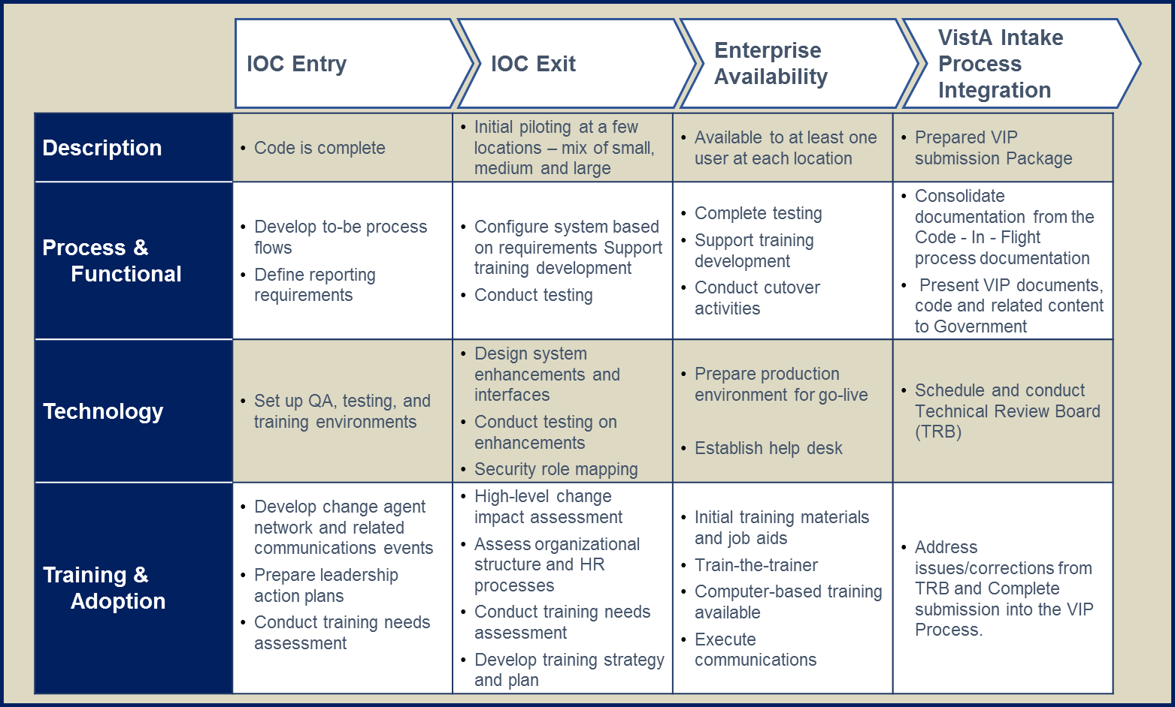

Figure 3. VistA Intake Lifecycle

### Lessons Learned

BITS has inculcated Lessons Learned and knowledge transfer as key to our corporate culture. We create Lessons Learned Reports (*Deliverable 5.5.A)* after every evolution and milestone or iteration to ensure we iteratively improve our responsiveness to stakeholder needs and increase our own organic efficiency. We actively mine our Lessons Learned by centralizing the reports in a searchable SharePoint directory enabling continuous learning and enhancement of our approach, tools, training, and communications. Truly learning from lessons captured requires ease of access and data mining to avoid the pitfalls and false steps of previous efforts for those aspects of intake into VistA Program within the control or influence of the team. We identify changes needed to a process, and determine if process improvement will benefit future actions. We document the necessary follow-up actions with the Lessons Learned Report to ensure process improvement recommendations are communicated to the appropriate group responsible for review, approval, and implementation. Our team will conduct lessons learned during and after Technical Review Board meeting and provide a Lessons Learn Report (*Deliverable 5.5A*). The goal of the Lessons Learn Report is to document items that can be improved and to document issues that may need additional consideration.

### Implementation Report

Considering the size and disparity of the organization, and variances in VistA, instantiations of a capability into the enterprise is a significant undertaking. There are no shortage of examples that can be cited where viable software was developed but user adoption lagged for a variety of reasons. Chief among them is the need for a stable product and constant communication with key stakeholders and adequate multi-modal training available to provide just-in-time training for clinicians. We understand and address stakeholder concerns about altering existing workflows, actively monitoring, querying and engaging stakeholders to create the Implementation Report *(Deliverable 5.5.B).* Upon the completion of IOC we will provide all configuration items of the OneVA capability to the COR for review. The BITS Team will attend the TRB and VIP Governance Board as needed to present the final product for acceptance and to address concerns and address open issues. After each TRB meeting a lessons learned meeting will be held and a report will document all discussion items, items of improvement, and any concerns that need to be considered by the TRB. Upon acceptance of the capability by the board an implementation report that summarizes all the activities performed in IOC and in final preparation for Vista intake will be delivered to the . All discrepancies in the instantiated instances of the capability will be the responsibility of BITS, pending VA assuming product operations and maintenance.

**Resources Supporting VistA Intake Program**

| **Labor Categories** | **Task 5** |
| --- | --- |
| Technical/Project Manager | 160 |
| SME-I | 120 |
| System Architect | 160 |
| Vista Developer | 160 |
| Project Coordinator | 0 |
| Trainer/Tech Editor | 80 |
| QA Tester | 160 |
| Test Lead | 270 |
| ***Total*** | 1110 |

**Deliverables**

|  |  |  |  |
| --- | --- | --- | --- |
| **Task** | **Description** | **Quantity** | **Due Date** |
| **5.5.A** | **Lesson Learned Reports** | TBD | * TRB meeting. |
| **5.5.B** | **Implementation Report** | 1 | * 60 day after contract ward and monthly thereafter |

# Labor Categories and Hours

The BITS Team offers experience that exceeds requirements. Table below provides the labor categories, and the position’s role and description in support of the five tasks for implementing OneVA Pharmacy.

| **Labor Categories** | **Task**  **1** | **Task**  **2** | **Task**  **3** | **Task**  **4** | **Task**  **5** | **Total** |
| --- | --- | --- | --- | --- | --- | --- |
| Technical/Project Manager | 220 | 120 | 280 | 160 | 160 | 940 |
| SME-I | 80 | 140 | 80 | 120 | 120 | 540 |
| System Architect | 40 | 160 | 340 | 240 | 160 | 940 |
| Vista Developer | 40 | 160 | 340 | 240 | 160 | 940 |
| Project Coordinator | 200 | 120 | 80 | 80 | 0 | 480 |
| Trainer/Tech Editor | 70 | 120 | 120 | 80 | 80 | 470 |
| QA Tester |  | 220 | 240 | 220 | 160 | 840 |
| Test Lead | 40 | 195 | 217 | 218 | 270 | 940 |
| ***Total*** | 690 | 1235 | 1697 | 1358 | 1110 | 6090 |

| **Program Role** | **Position Description** |
| --- | --- |
| **Technical/Project Manager** | Provides oversight and executive level management for large, multiple, and/or complex projects often involving multiple sub-projects/tasks or groups of personnel at multiple locations. Maintains and manages relationships with senior level client management, including coordination and communication of overall program status; Resolves problems, issues, risks, or conflicts as required; Ensures that program schedule, performance, and deliverables are satisfied within established program standards for quality and work performance. Education Level: Bachelor’s degree in related field or equivalent, with 12 years of experience. |
| **SME-I** | Registered Nurse (BS or BSN) with advanced training or experience in healthcare information systems (Master’s or board certification in clinical informatics preferred). Demonstrated experience in federal government healthcare systems, clinical medicine, healthcare and project management. Assists government AIM analysts with clinically specific requirements in health or business systems. Acts as liaison with clinical business owners, assisting with translation of needs into developer/contract specific terminology and documentation. Will advise and assist with clinical coordination and clarification of requirements and design and act as the OneVA Pharmacy Implementation Clinical Lead. |
| **System Architect** | 15 + years’ coding experience in the analysis, design, development, testing and maintenance of software including prototype, web-based and enterprise applications. Expertise in designing and implementing complex enterprise applications using various technologies. Demonstrated ability to create ad hoc, proof of concept, and prototype solutions. |
| **Vista Developer** | 5+ coding experience in the analysis, design, development, testing and maintenance of software including prototype, web-based and enterprise applications. Expertise in designing and implementing complex enterprise applications using various technologies. Demonstrated ability to create ad hoc, proof of concept, and prototype solutions. Will assist Senior MUMPS Developer in coding OneVA Pharmacy enhancements and options. |
| **Project Coordinator** | Supports the project in all facets of lifecycle coordination required with stakeholders, review organizations and meeting scheduling. Project Coordinator role on the OneVA Pharmacy implementation team will concurrently manage multiple support roles required in a VA modified PMAS environment. Responsibilities include creating and maintaining the project schedule and managing risk as the Risk Manager. Duties also include assisting the PM and technical writer with creation and maintenance of PMAS artifacts. |
| **Training/Technical Writer** | Technical writing and documentation and artifact creation support of PMAS project artifacts supporting the OneVA Pharmacy Implementation project. Extensive knowledge and experience in PMAS/ProPath required. Also assists with coordinating required Milestone Review artifacts in conjunction with project coordinator. |
| **Quality Assurance Tester** | Review Project Artifacts, works with project team to define and create overall strategy and ensures that it is being achieved. Communicates the test strategy to the Project Manager and Development Team, defines test process including required test activities and deliverables. Identifies test resources, estimates test effort and defines test schedule and milestones. Ensures technical resources are organized for effective support of testing. Conducts walk-through of Test Strategy and approves Test Cases. On the OneVA Pharmacy Implementation team the QA Lead will also function as the Release Manager. |
| **Test Lead** | Review Requirements, review logical and Physical Designs. Collaborate with Quality Assurance to create Test Plan and participate in walk-through of Test Plan. Execute Test Plan. Create Test Cases (manual and automated, if applicable) and Requirements matrix. Conduct walk-through of test cases. |